Project Report
on
HEART DISEASE PREDICTION USING MACHINE LEARNING
by
ROSHAN V.C (RA2231241020040)
Submitted to the
DEPARTMENT OF COMPUTER SCIENCE AND APPLICATIONS (BCA)
Under the guidance of
Dr.E.SRIMATHI
Assistant Professor
Submitted in partial fulfillment of the requirement
for the award of the degree of
BACHELOR OF COMPUTER APPLICATIONS



SRM INSTITUTE OF SCIENCE AND TECHNOLOGY
Ramapuram,Chennai
April 2025

FACULTY OF SCIENCE & HUMANITIES
Ramapuram Campus
__________________________________________________________________
DEPARTMENT OF COMPUTER SCIENCE & APPLICATIONS (BCA)

BONAFIDE CERTIFICATE

Certified that this project report titled “HEART DISEASE PREDICTION USING MACHINE LEARNING” is the bonafide work of ROSHAN V.C (RA2231241020040) who carried out the “UCA20D10J- PROJECT WORK” done under my supervision.

Certified further, that to the best of my knowledge the work reported here in does not form part of any other project report on the basis of which a degree or award was conferred on an earlier occasion on this or any other candidate.

Signature of Internal Guide Signature of Head of the Department

Signature of Internal Examiner Signature of External Examiner

COMPLETION CERTIFICATE

COMPANY PROFILE

Signa Tech Solutions LLC is a globally recognized IT services and digital transformation company headquartered in Brookfield, Wisconsin, USA, with a subsidiary, Signa Tech Services Private Limited, based in Chennai, India. With a strong focus on healthcare, life sciences, medical devices, and manufacturing industries, the company delivers cutting-edge solutions designed to drive efficiency, innovation, and business growth. Its core services include Digital Transformation, Remote Infrastructure Management (RIM), Data Analytics & BI Solutions, DevOps, Cloud Services, and Business Process Outsourcing (BPO). Signa Tech leverages advanced technologies such as AI, IoT, and automation to help clients optimize operations, reduce costs, and enhance decision-making through intelligent insights
A key differentiator for Signa Tech is its domain-specific expertise, particularly in healthcare, where it provides solutions like claims analytics, cloud migration, and patient engagement portals, and in manufacturing, where it enables IoT-driven automation, inventory analytics, and smart supply chain management. The company boasts a robust technology stack, including .NET, React, Angular, Power BI, Tableau, Azure, AWS, and Snowflake, ensuring scalable and secure digital solutions.Signa Tech also operates STAIR Progressive Minds Pvt Ltd, its training and skill development arm, which bridges the gap between industry demands and academic readiness. STAIR offers psychometric assessments, business agility workshops, AI & data science training, and corporate readiness programs, empowering professionals and students with mission-critical skills.With a 90% employee retention rate, a hybrid staffing model (managed resources, shared outsourcing, and fully outsourced services), and a strong emphasis on security and compliance, Signa Tech ensures reliability and continuity for its clients.
The company is led by CEO Siva Dakshinamurthy and a leadership team with over 30 years of international IT experience, fostering a culture of innovation, partnership, and excellence.

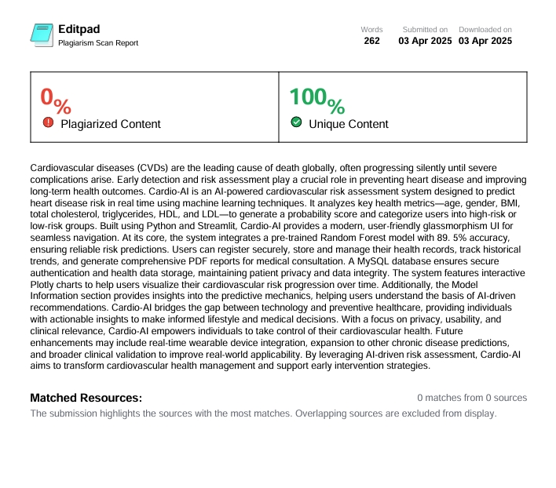
PLAGIARISM SCAN REPORT

Heart Disease Prediction Using Machine Learning
ABSTRACT
Cardiovascular diseases (CVDs) are a leading cause of global mortality, underscoring the need for early detection and risk assessment. Cardio-AI is an AI-powered clinical decision support system designed to predict heart disease risk using a pre-trained Random Forest model with 89.5% accuracy. Developed with Python and Streamlit, it analyzes key health metrics—age, gender, BMI, total cholesterol, triglycerides, HDL, and LDL—to provide real-time probability scores and risk categorization (High/Low).
The system features a modern glassmorphism UI, offering seamless navigation across its core modules: Home, Risk Assessment, Patient Profile, and Model Information. Users can securely register, manage health profiles, track historical data, generate detailed PDF reports, and visualize risk trends with interactive Plotly charts. A MySQL database ensures secure user authentication and health data storage, managed by a custom DatabaseManager class for robust data persistence.
Cardio-AI is designed with a strong focus on privacy, usability, and clinical relevance, providing actionable insights for individuals and healthcare professionals to support preventive cardiovascular care. By leveraging machine learning and interactive analytics, it bridges the gap between technology and healthcare, empowering users with AI-driven early warning tools.
Future enhancements may include real-time wearable data integration, expanded predictive capabilities for other chronic conditions, and broader clinical validation to improve its accuracy and adoption in real-world medical settings.

SRM INSTITUTE OF SCIENCE AD TECHNOLOGY, RAMAPURAM
FACULTY OF SCIENCE AND HUMANITIES
Chennai , Ramapuram - 600 089
DEPARTMENT OF COMPUTER SCIENCE AND APPLICATIONS
BCA
A Final Project Report
Academic Year:2024 – 2025 | Batch:2022-2025
Project Title
HEART DISEASE PREDICTION USING MACHINE LEARNING

Project Work towards 17 SDGs is mapped as follows:
 |  | Target 3.4: "By 2030, reduce by one third premature mortality from non-communicable diseases through prevention and treatment and promote mental health and well-being."
 |  | Target 4.7: "By 2030, ensure that all learners acquire the knowledge and skills needed to promote sustainable development, including, among others, through education for sustainable development and sustainable lifestyles, human rights, gender equality, promotion of a culture of peace and non-violence, global citizenship, and appreciation of cultural diversity and of culture’s contribution to sustainable development."
 |  | Target 9.5: "Enhance scientific research, upgrade the technological capabilities of industrial sectors in all countries, in particular developing countries, including, by 2030, encouraging innovation and substantially increasing the number of research and development workers per 1 million people and public and private research and development spending."

ACKNOWLEDGEMENT
I extend my sincere gratitude to the Chancellor Dr. T.R.PACHAMUTHU and to Chairman Dr. R. SHIVAKUMAR of SRM Institute of Science and Technology, Ramapuram and Trichy campuses for providing me the opportunity to pursue the BCA degree at our esteemed University.
I express my sincere gratitude to Dr.S.Thirumagan, DEAN(S&H), SRM IST, Ramapuram for his support and encouragement for the successful completion of the project.
I am thankful to Dr. J. Dhillipan M.Sc., MBA., M.Phil., Ph.D., HOD and Vice Principal-Admin (S&H), SRM IST, Ramapuram, for his support and encouragement for the successful completion of the project.
I record my sincere thanks to Dr.S. Uma Shankari MCA., M.Phil., Ph.D., NET., SET., MSc., Associate Professor Program Coordinator, Department of Computer Science & Applications (BCA), SRM IST, Ramapuram for her continuous support and keen interest to make this project a successful one.
I find no word to express profound gratitude to my guide Dr.E.Srimathi, Department of Computer Science & Applications (BCA), SRM IST Ramapuram.
I thank the almighty who has made this possible. Finally, I thank my beloved family member and friend for their motivation, encouragement and cooperation in all aspect which led me to the completion of this project.

ROSHAN.V.C
RA2231241020040

TABLE OF CONTENTS
S.NO | TITLE | PAGE NO
 | ABSTRACT  SDG MAPPING  ACKNOWLEDGEMENT  LIST OF TABLES  LIST OF FIGURES | i  ii  iii  vii  vii
CHAPTERS | TITLE | PAGE NO.
1 | INTRODUCTION  - PROJECT INTRODUCTION | 2
2 | WORKING ENVIRONMENT  2.1 HARDWARE REQUIREMENT  2.2 SOFTWARE REQUIREMENT  2.3 SYSTEM SOFTWARE | 4  4  5
3 | SYSTEM ANALYSIS  3.1 FEASIBILITY STUDY  3.2 EXISTING SYSTEM  3.3 DRAWBACKS OF EXISTING SYSTEM  3.4 PROPOSED SYSTEM  3.5 BENEFITS OF PROPOSED SYSTEM  3.6 SCOPE OF THE PROJECT  3.7 BENEFITS TO SOCIETY | 7  7  7  8  8  8  9
4 | SYSTEM DESIGN  4.1 DATA FLOW DIAGRAM  4.2 USE CASE DIAGRAM  4.3 ARCHITECTURE DIAGRAM  4.4 DATABASE DESIGN  4.5 ACTIVITY DIAGRAM | 11  12  13  14  15
5 | PROJECT DESCRIPTION  5.1 OBJECTIVE  5.2 MODULE DESCRIPTION  5.3 IMPLEMENTATION  5.4 USER AUTHENTICATION  5.5 DATA STORAGE & SECURITY  5.6 RISK PREDICTION & VISUALIZATION  5.7 PDF REPORT GENERATION | 17  17  18  21  21  21  21
6 | SYSTEM TESTING  6.1 TESTING DEFINITION  6.2 TESTING OBJECTIVE  6.3 TYPES OF TESTING  6.4 TEST CASES | 23  23  23  25
7 | CONCLUSION  7.1 SUMMARY  7.2 FUTURE ENHANCEMENTS | 27  27
8 | APPENDIX  8.1 SCREENSHOTS  8.2 CODING  8.3 DATA DICTIONARY | 29  36  67
9 | BIBLIOGRAPHY AND REFERENCES | 68

LIST OF TABLES

S.NO | Tab. No. | Table Name | Page No.
1 |  | USER AUTHENTICATION DATA | 21
2 |  | DATABASE SCHEMA OVERVIEW | 14

LIST OF FIGURES

S. No | Figures Name | Page No.
1 | DATAFLOW DIAGRAM | 11
2 | USECASE DIAGRAM | 12
3 | SYSTEM ARCHITECTURE DIAGRAM | 13
4 | DATABASE DIAGRAM | 14
5 | ACTIVITY DIAGRAM | 15
6 | HOME PAGE UI IMPLEMENTATION | 29
7 | PREDICTION PAGE UI IMPLEMENTATION | 33
8 | RISK ASSESSMENT PAGE UI IMPLEMENTAION | 33
9 | MODEL INFO PAGE IMPLEMENTAION | 34
10 | PROFILE PAGE IMPLEMENTAION | 35

